horizontal line

**Calling REST Service from Process**

Calling a REST service from a process involves two steps:

1. Create a work item handler for Rest
2. Create a REST service and configure the REST call parameters

**Create a work item handler for REST**

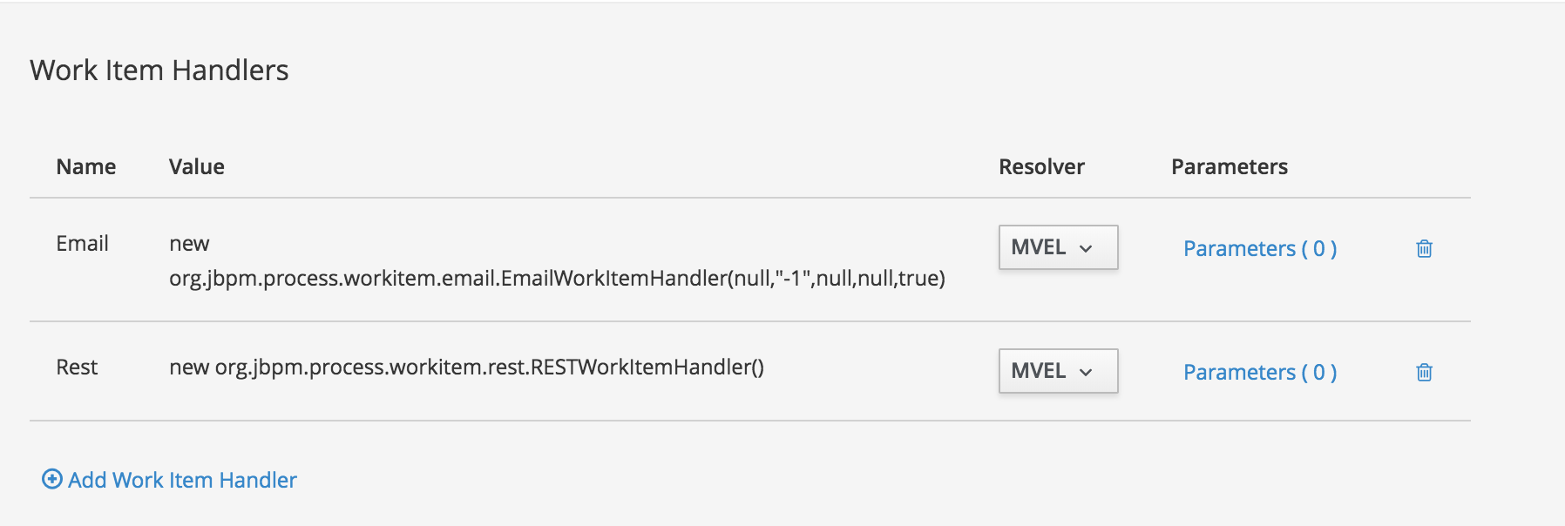

Create a work item handler as shown above by navigating to Project Settings -> Deployments -> WorkitemHandlers.

**Create a REST service and configure the REST call parameters**

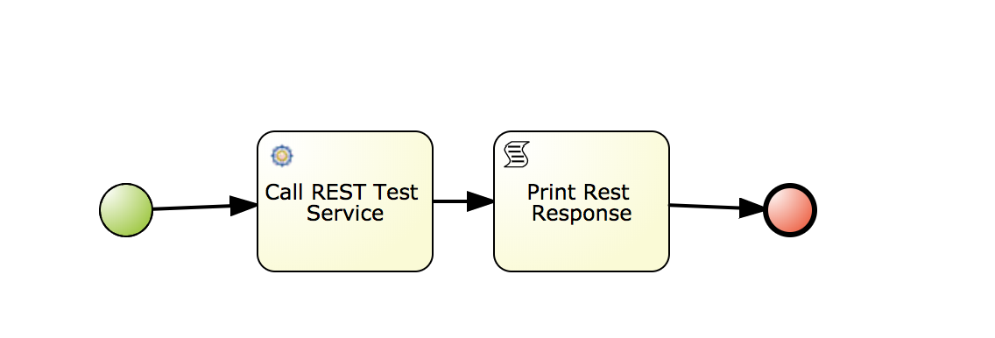

Open up the property pane and we will now add the parameters to make the REST call.

Click on assignments.

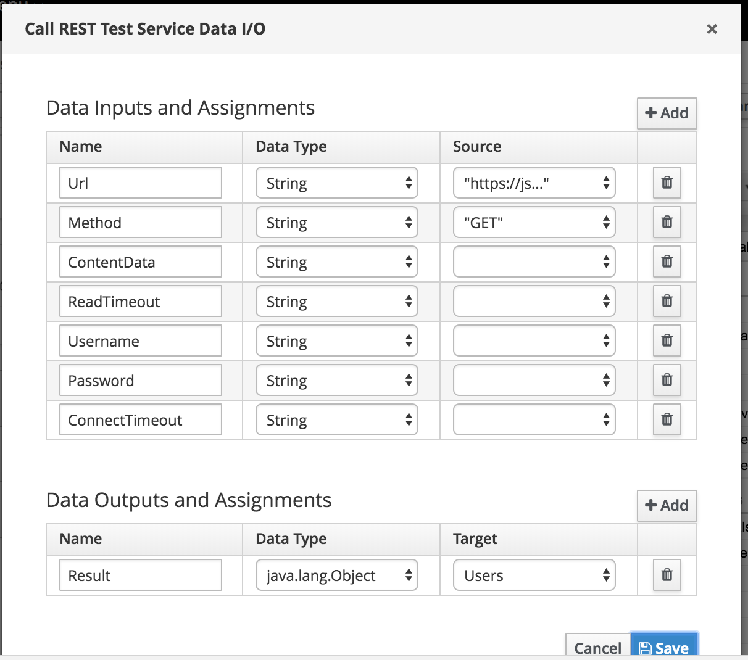

For the purpose of the test, i am using a json test REST endpoint.

GET <https://jsonplaceholder.typicode.com/users>

[  
 {  
 "id": 1,  
 "name": "Leanne Graham",  
 "username": "Bret",  
 "email": "Sincere@april.biz",  
 "address": {  
 "street": "Kulas Light",  
 "suite": "Apt. 556",  
 "city": "Gwenborough",  
 "zipcode": "92998-3874",  
 "geo": {  
 "lat": "-37.3159",  
 "lng": "81.1496"  
 }  
 },  
 "phone": "1-770-736-8031 x56442",  
 "website": "hildegard.org",  
 "company": {  
 "name": "Romaguera-Crona",  
 "catchPhrase": "Multi-layered client-server neural-net",  
 "bs": "harness real-time e-markets"  
 }  
 },

…..

Since this endpoint does not have an authentication policy on it, we just add the method name in this case GET, and the URL of the resource we are fetching.

We output the target data on to a Users Object.

Once the configuration is complete, build and deploy.

When executed you can see that the REST call is executed by the task and the result data is fetched on the Users Object.

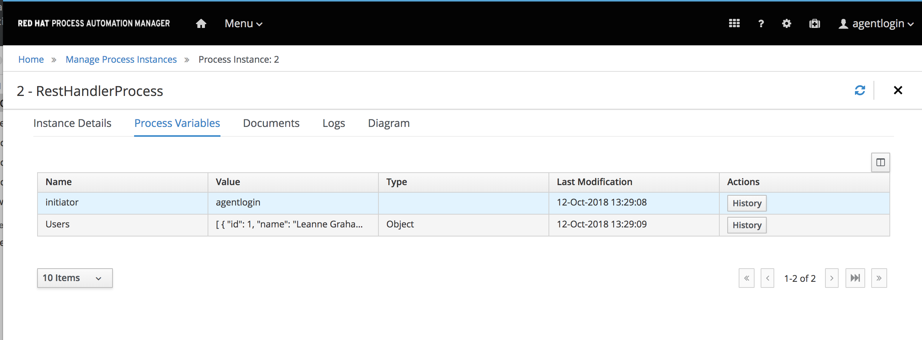

GitHub project can be found at

https://github.com/anurag-saran/fid-poc